Notes

Morocco Part

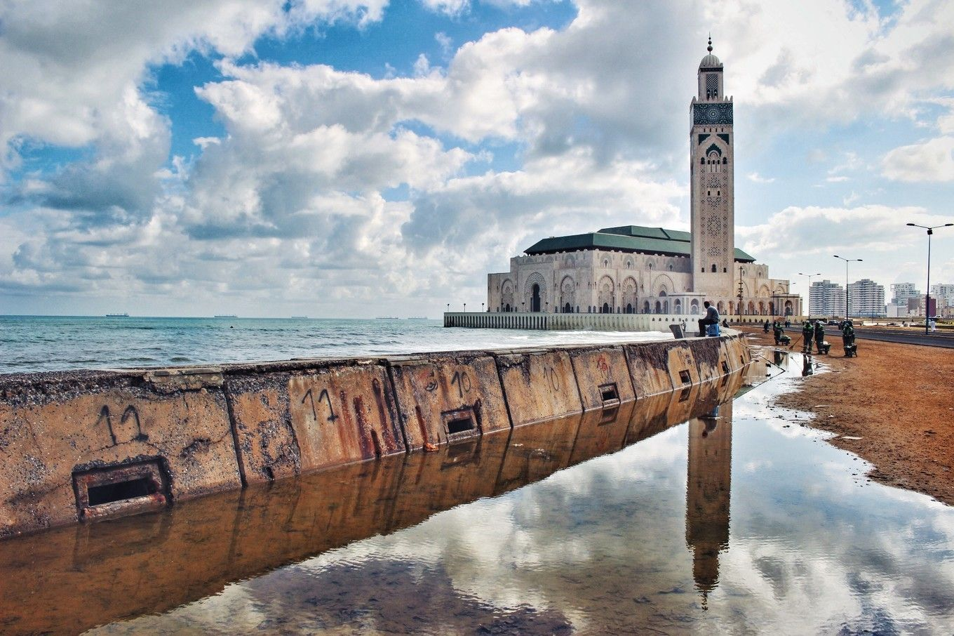

throne of aqua, (flame),

First session:

* 2/11 Sat, SL 130A, pay $100
* Intro to modern Morocco, architecture, education system, politics, Western Sahara problem, Green walk. (Government structure);
* French alphabet and simple words.

Materials:

* Moroccan Architecture:

https://www.youtube.com/watch?v=iAdJvv9U9Co

* Moroccan stories:

<https://drive.google.com/drive/u/0/folders/0B83nljbpR36vM001Rm15bnNaN2M?usp=drive_web>

(Education system, English-learning, how, when, why )

* French alphabet:

<https://www.youtube.com/watch?v=tywHA5Qys-Y>

Assignments:

3 questions(mess)

“R” words

Second Session:

* 3/12 Sun, SL 379, 3-5pm
* Tangier port; Fishing permission as some kind of trade; ‘No pet’
* Check French alphabet, rasin, rhum, revoir, rouge,

Materials:

* Resources:

<https://www.youtube.com/watch?feature=share&v=IlGKCsFTnYk&app=desktop>

(why invest Morocco)

* King Hassan II

<https://www.youtube.com/watch?v=SgcEg0EsPFc>

<https://www.youtube.com/watch?v=UYtw61uuk8A>

<https://www.youtube.com/watch?v=n4HaC1qat-E>

Assignments:

Number, color, family

History frame/index